Baldivis Secondary College Name:____________________
Mathematics Foundation Program UNIT 3 Semester 1

Task 6: Skills Test: Location, Time and Temperature

Task weighting: 7% of the school mark for this pair of units

Conditions: Calculator Permitted Time for the task: 55 minutes Marks: /36 marks

Question 1

Map of the Central Business District of Melbourne.

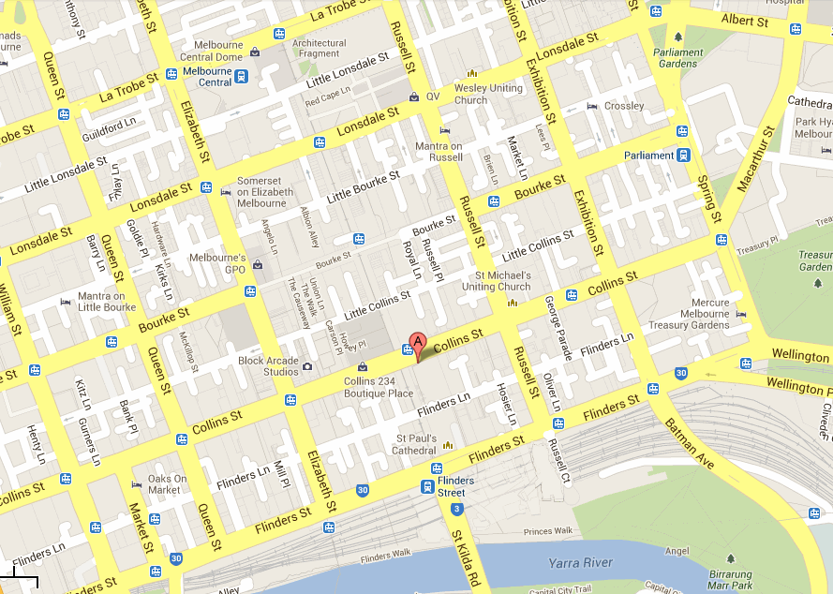
B

Scale 1 : 20 000 (1 cm = 200 m)

1 | 7 marks (2, 2, 3)  You are on holidays with a friend in Melbourne and decide to walk around the city of Melbourne. You are located at (A) on Collins Street.
(a) | Describe in words how you would walk to Parliament Gardens on Albert Street.
(b) | Using the given scale how far is it to walk to Flinders Street Station opposite St Paul’s Cathedral from the corner of Queens Street and Flinders street?
(c) | You wish to walk to the Mercure Melbourne Treasury Gardens (B), walking along Collins Street. If you are walking at a speed of 100 metres per minute, how long would it take you to walk the distance?

Question 2

10 marks (2, 2, 2, 2, 1, 1)
 | How many hours and minutes between:
(a) | 10:00 a.m. and 6:00 p.m.? |  | (b) |  |  | 8:35 a.m. and 5:15 p.m.?
 | Write each of the following times using both 12-hour and 24-hour time:
(c) | 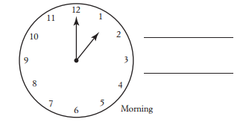 |  |  |  |  |  | (d) |  | 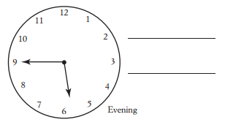
 | Write each of the following in 12-hour time, using numbers:
(e) | ‘twenty-five minutes after one’ in the morning |  |  |  |  | (f) |  |  | ‘ten minutes before three’ in the daytime

Question 3

6 marks (2, 2, 2)
 | 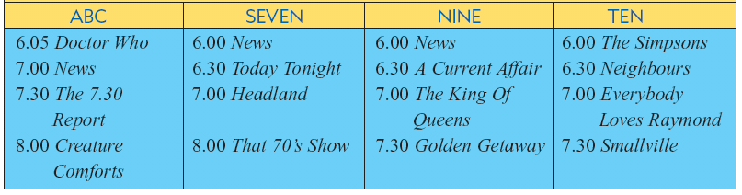
(a) | At what time do the following programs begin |  |  |  | (b) |  |  | How long are each of the following programs?
(i) | Neighbours |  |  |  | (i) |  |  | Doctor Who
(ii) | Creature Comforts |  |  |  | (ii) |  |  | The Simpsons
(c) | If you just finished watching Doctor Who, how long do you need to wait to see that 70’s Show?

Question 4
8 marks ( 2, 1, 1, 2, 2)
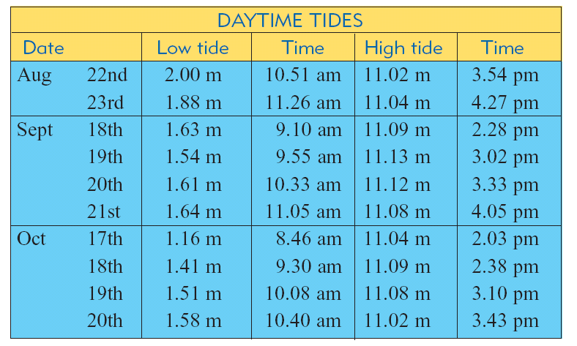
The table below gives the heights and times of high and low tides for several days over 3-month period.

(a) | On 19th September what is the height of the high tide and when does it occur?
(b) | On 18th September:
(i) | When do the low and high tide occur? |  |  | (ii) |  |  | What is the time difference between the low and the high tide?
(c) | Emily believes that it is best to go fishing half an hour after a high tide. If this is true what would be the best time to go fishing on October the 18th

Question 5

5 marks (1, 1, 2, 1)
 | Minimum Temperature Perth | Maximum Temperature Perth |  |  |  |  |  |  |  | (a) | Write the minimum temperature in degrees Celsius.
 | 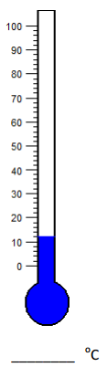 | 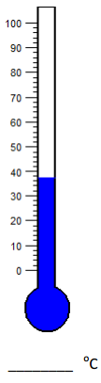
 |  |  |  |  |  |  |  |  |  | (b) | Write the maximum temperature in degrees Celsius.
 |  |  |  |  |  |  |  |  |  | (c) | What is the range of temperature for that particular day?
 |  |  |  |  |  |  |  |  |  | (d) | What season would you likely expect this range of temperatures in Perth.

